CHAPTER IV
RESULTS AND DISCUSSION
This chapter presents the results in initial testing of the sensors and materials as well as the testing the prototype of this wireless data logging platform.
4.1 Intial Testing
4.1.1 CC1101 RF Transceiver
4.1.1.1 Range Test
To verify to effective range of the CC1101 transceivers, range test was done with a dummy node sending data stream from one (1) to twenty (20). The farthest range where in there is no occurrence of drop in the data stream is considered as the effective range.
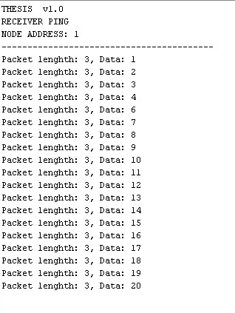
Figure 4.1 Sample Data Stream in Range Test
Shown in figure 4.1 is the sample data stream sent by the dummy node into the receiver node. No data sent thru the CC1101 transceiver should be ignored to maximize the quality of service of the system. Thus, effective range should be calculated to know the limit of the distance between the sensor node and the receiver node considering the obstacles in the communication.
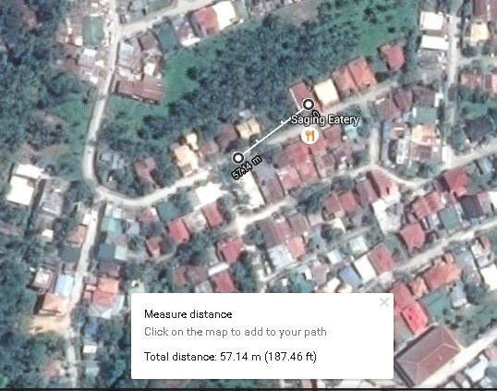
Figure 4.2 Effective CC1101 communication range
Google earth application was used to verify the effective range of the system. As shown in figure 4.2, the maximum distance the CC1101 could communicates without data loss is 57.14 meters (187.46 feet). To ensure quality of service, it is advisable for all of the sensor nodes to be within a radial distance not more than 55 meters from the receiver node.

4.1.1.2 Data Transmission Reliability
After having the pulse rate and temperature data validated, the data will be transmitted into the receiver node thru the CC1101 transceiver. Throughout the communication of the transceivers, it is important that the data sent by the sensor nodes should be the same with the data received in the receiver node.
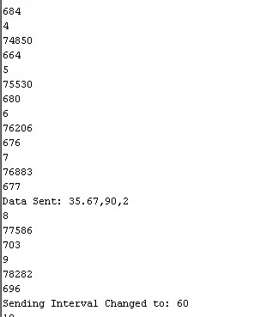
Figure 4.3 Data Transmitted by Sensor Node
Shown in figure above is the data gathered by sensor node with address 2 transmitted into the receiver node. As shown in the figure, the said sensor gathered a temperature of value 35.67 °C and a pulse rate value of 90 bpm. The data were sent into the receiver node with address 1.
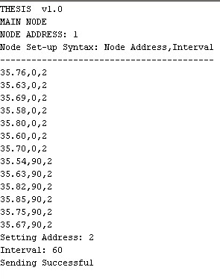
Figure 4.4 Data Received by Receiver Node
For the system to pass the transmission reliability test, the data sent by address 2 must coincide with the data received in the receiver node with address 1. As shown in the figure above, the data sent by address 2 is exactly the same with the data sent with temperature value of 35.67 °C and a pulse rate value of 90bpm.
4.1.2 Temperature Sensor
The temperature sensor MLX90614 is capable of getting ambient and object temperature without the need of direct contact for data acquisition. To validate the data gathered, the test subject must also be tested using the conventional temperature data gathering which is by using thermometer. In the validation process, a digital thermometer was used which beeps as soon as a valid temperature is gathered.

Tests | Device Reading (T_{a}) | Thermometer Reading (T_{b}) | Difference  (T_{a} - T_{b})
1 | 35.38 | 35.1 | 0.28
2 | 35.30 | 35.1 | 0.20
3 | 35.35 | 35.3 | 0.05
4 | 35.35 | 35.4 | -0.05
5 | 35.38 | 35.5 | -0.12
6 | 35.30 | 35.4 | -0.10
7 | 35.31 | 35.4 | -0.09
8 | 35.29 | 35.4 | -0.11
9 | 35.33 | 35.3 | 0.03
10 | 35.36 | 35.3 | 0.06
 |  | Ave Difference: | 0.015
Table 4.1 Temperature readings comparison between the thermometer and MLX90614
Shown in the table above are the temperature data gathered from a person by using both thermometer and the temperature sensor used for the device which is the MLX90614 infrared thermometer. Ten (10) temperature samples were gathered in each of the instruments every minute and were subtracted to get the temperature difference in each interval. As seen in the table above, the average temperature difference between the two instruments is 0.015 °C. This calculated temperature difference was added into the algorithm of the MLC90614 temperature sensor as a compensation temperature to get a more reliable reading.
4.1.3 Pulse Rate Sensor
Since time is a great factor in determining the pulse rate of a person, proper data acquisition must be done to attain a valid data. The data gathered from the pulse rate sensor shall be compared with the manual counting of pulse rate over a period of time. However, during the initial testing, sudden rise and drop of pulse rate occurs whenever a person moves or the ear clip is altered. To correct such problem, 20 samples of pulse rate interval in millis were gathered and averaged to get the mean for the pulse interval. This will then be divided into 60 seconds to get the occurrences of pulse over a minute. Also, several samples of pulse rate were gathered and averaged to attain a minimum difference compared to the manual pulse rate gathering.
4.2. Test Cases
4.2.1 Single Node Communication
The measured data were set-up in the following syntax: temperature, pulse rate, node. The time interval was set into seconds. Sensor nodes were tested if they were able to gather data from a mobile test subject and to transmit the measurements successfully.
Figure 4.5 Data received from address 2
Shown in figure 4.5 is the post transmission data sent from sensor node 2 to node 1; the receiver node. Upon start-up, the default reading of pulse rate is zero and the sending interval is 5 seconds. The data received by the receiver node as shown in the figure above demonstrates single node communication between the receiver node and the sensor node with address 2.
4.2.2 Multi Node Communication
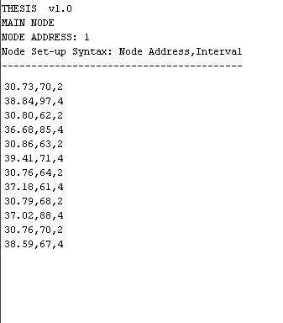
Figure 4.6 Data received from addresses 2 and 4
To verify whethere the system is capable of communicating in multinode, the receiver must be able to receive data from two (2) or more sender nodes. As shown in the figure above, the receiver node with address 1, was able to simultaneously receive temperature and pulse rate data from addresses 2 and 4.

4.2.3 Sending Interval Variation
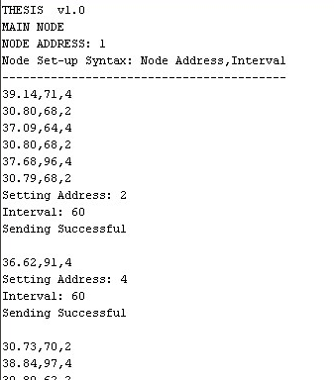
Figure 4.7 Sender nodes data sending interval variation
As shown in the figure above, the receiver node was able to manipulate the sending interval of sender nodes with addresses 2 and 4 based on its prescribed interval of 60 seconds.

4.2.4 Error Detection
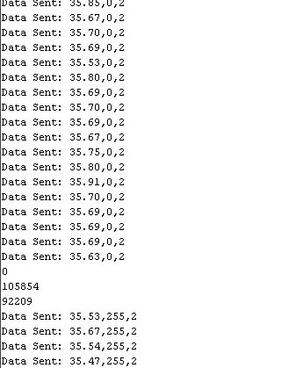
Figure 4.8 Error data transmitted from sensor node with address 2
To demonstrate an error in the system, the pulse rate ear clip was left hanging to be able to acquire a pulse rate interval of more than 2000 millis or 2 seconds. As shown in the figure above, a pulse rate interval of 92209 millis or 92.209 seconds was returned which is more than the maximum interval set in the pulse rate algorithm of value 2000 millis. As soon as a pulse rate interval exceeds 2000 millis, a 255 value of bpm was transmitted into the receiver node.
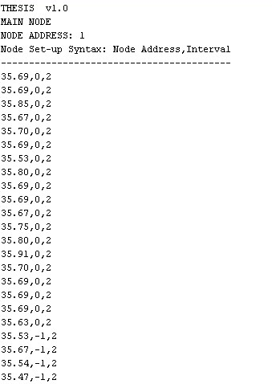
Figure 4.9 Error detection data received by the receiver node
The receiver node was programmed to display a -1 value of pulse rate from any sender node as soon as a 255 value of pulse rate is received. In the figure above, a -1 value of pulse rate was received from address 2. This would warn the user that there are irregularities in the sensor node attached to a person. This may tell him that the pulse rate sensor is defective or the ear clip needs reattachment.

